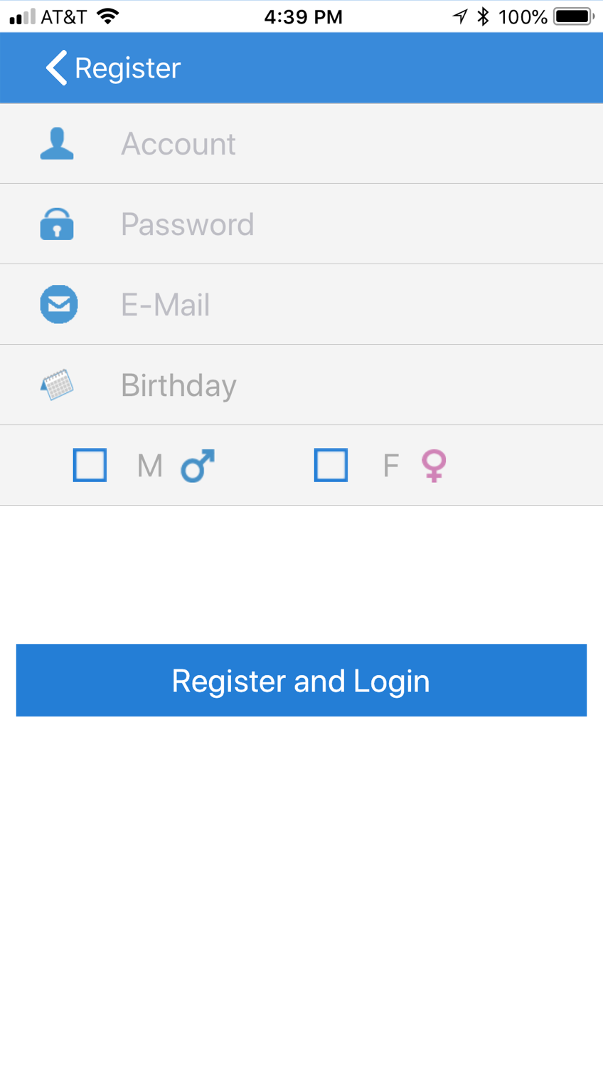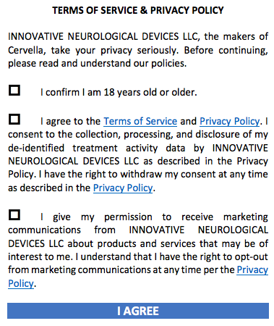

**TERMS OF SERVICE & PRIVACY POLICY**

INNOVATIVE NEUROLOGICAL DEVICES LLC, the makers of Cervella, take your privacy seriously. Before continuing, please read and understand our policies.

* I confirm I am 18 years old or older.
* I agree to the [Terms of Service](https://cervella.us/terms-of-service) and [Privacy Policy](https://cervella.us/privacy-policy). I consent to the collection, processing, and disclosure of my de-identified treatment activity data by INNOVATIVE NEUROLOGICAL DEVICES LLC as described in the Privacy Policy. I have the right to withdraw my consent at any time as described in the [Privacy Policy](https://cervella.us/privacy-policy).
* I give my permission to receive marketing communications from INNOVATIVE NEUROLOGICAL DEVICES LLC about products and services that may be of interest to me. I understand that I have the right to opt-out from marketing communications at any time per the [Privacy Policy](https://cervella.us/privacy-policy).

**I AGREE**

**Cancel**

**NOTES:**

User MUST at least click 1st AND 2nd checkbox to proceed. If user does not click 3rd box but clicks 1st and 2nd, he or she can advance. Maybe the “I AGREE” box is gray first and when user clicks 1st and 2nd box, it turns blue like above.

用户必须至少单击“第一”和“第二”复选框才能继续。如果用户不点击第三个方块，而是点击第一和第二，他或她可以前进。也许“我同意”框是灰色的第一次，当用户点击第一和第二框，它变成蓝色以上。

The links to Terms of Service and Privacy Policy are as follows:

Terms of Service: <https://cervella.us/terms-of-service>

Privacy Policy: <https://cervella.us/privacy-policy>